Natural Language Processing
2. Word Level Analysis
2.1 Tokenization, Stemming, Segmentation, Lemmatization, Edit Distance, Collocations, Finite Automata, Finite State Transducers (FST), Porter Stemmer, Morphological Analysis, Derivational and Reflectional Morphology, Regular expression with types.
2.2 N –Grams, Unigrams/Bigrams Language Models, Corpora, Computing the Probability of Word Sequence, Training and Testing.
PAST QUESTIONS:
- Explain FSA for nouns and verbs. Also design a Finite State Automata (FSA) for the words of English numbers 1-99. (D23)
- Illustrate the concept of tokenization and stemming in Natural Language Processing. (M24)
- Explain inflectional and derivational morphology with an example. (M24)
- What is language model? Write a note on N-gram model. (D24)
- Explain Porter’s Stemming algorithm with example. (D23, M24, D24, M25)
- (M25)
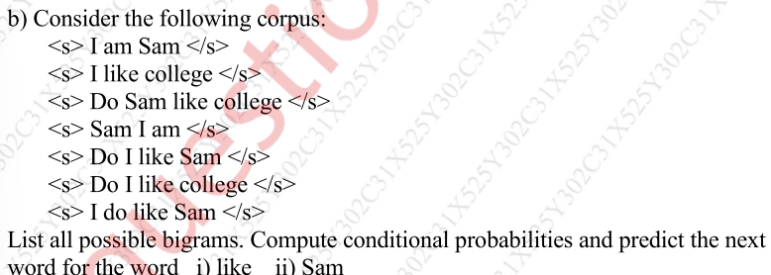

NOTES:

*Tokenization :-
Tokenization involves dividing a Textual input into smaller units known as tokens. These tokens can be in the form of words, characters, sub-words, or sentences. The process of splitting a text into smaller units such as words, sentences, or subwords.
Example: "I love NLP" → ["I", "love", "NLP"]

*Stemming :-
Stemming A rule-based process of removing word affixes to obtain the word stem.
Reduces a word to its base or root form by chopping suffixes/prefixes, often without considering grammar.
Example: "playing", "played" → "play"
Another phrase example:
Input: obesity causes many problems
Output: obes caus mani problem
*Segmentation :-
Segmentation is the process of dividing a continuous stream of text or speech into smaller meaningful units so that they can be further analyzed.
Breaking text into meaningful segments, especially useful for languages without spaces
Example: "Ilovecats" → "I | love | cats"

*Lemmatization :-
Lemmatization Reduces words to their dictionary base form (lemma) using a dictionary and rules.
Example: "better" → "good", "running" → "run"
Example:
Input: obesity causes many problems
Output: obesity cause many problem

*Edit Distance :-
It is the minimum number of operations (insertions, deletions, substitutions) required to transform one string into another.
Example: "kitten" → "sitting" needs 3 edits (substitute k→s, substitute e→i, insert g).

*Collocations :-
Words that frequently occur together in natural language and sound “natural” as a pair/group.
Collocations are two or more words that tend to appear frequently together.
Example: "strong tea" (not powerful tea), "make a decision", "fast food".

*Porter Stemmer Algorithm :-
Porter's Stemmer is one of the most popular and widely used stemming algorithms proposed in 1980 by Martin Porter. It simplifies words by reducing them to their root forms, a process known as "stemming." For example, the words "running," "runner," and "ran" can all be reduced to their root form, "run."
Unlike lemmatization, it does not use a dictionary; it just applies heuristic rules.
The Porter Stemmer works by applying a series of rules to remove suffixes from words in five steps. It identifies and strips common endings, reducing words to their base forms (stems). For example, "eating" becomes "eat" and "happily" becomes "happi." This helps in text analysis by standardizing word forms.
The algorithm applies rules in several phases (steps). Each step has a set of suffix-stripping rules with conditions:
- Step 1a: Deals with plurals and past participles.
  - caresses → caress
  - ponies → poni
  - ties → ti
- Step 1b: Deals with -ed and -ing.
  - plastered → plaster
  - motoring → motor
- Step 2: Removes common suffixes like -ational, -izer, -fulness.
  - relational → relate
  - conditional → condition
  - rationalize → rational
- Step 3: Removes -icate, -ative, -alize.
  - triplicate → triplic
  - formative → form
- Step 4: Removes suffixes like -al, -ance, -ence, -ment, -ous.
  - formal → form
  - callousness → callous
- Step 5: Final clean-up (remove -e, -l in certain cases).
  - probate → probat
  - controll → control
Original words: ['running', 'jumps', 'happily', 'programming']
Stemmed words: ['run', 'jump', 'happi', 'program']

Limitations –
- It can produce stems that are not meaningful, such as turning "iteration" into "iter."
- The algorithm is primarily designed for English and may not work well with other languages.
- Compared to other stemmers, it may remove suffixes more aggressively, making words more similar to each other.
- Different words may be reduced to the same stem, resulting in a loss of meaning.

*Morphological Analysis :-
In NLP, morphological analysis is the process of breaking down words into their smallest meaningful units, called morphemes (like roots, prefixes, and suffixes), to understand a word's internal structure and meaning. This fundamental task involves tasks like stemming (reducing words to a root form) and lemmatization (reducing words to their dictionary form) and is essential for various NLP tasks, including language modeling, text analysis, and machine translation.
Example:
In the word "unhappiness," the morphemes are "un-" (prefix), "happy" (root), and "-ness" (suffix).

Inflectional morphology:
Inflectional morphology deals with adding suffixes or prefixes to a word to express tense, number, gender, case, person, comparison, etc., without changing the word’s core meaning or category.
Modifies a word to express grammatical features (tense, number, gender, case).
Examples:
- walk → walked (tense)
- cat → cats (plural)
- big → bigger (comparison)

Derivational morphology:
Derivational morphology is the branch of morphology that creates new words by adding prefixes or suffixes (derivational affixes) to a base/root word. These changes often modify the meaning of the word and may also change its grammatical category (noun → adjective, verb → noun, etc.).
Forms a new word by adding affixes.
Example: happy → happiness, kind → unkind.

*Language model :-
A language model in natural language processing (NLP) is a statistical or machine learning model that is used to predict the next word in a sequence given the previous words. Language models play a crucial role in various NLP tasks such as machine translation, speech recognition, text generation, and sentiment analysis. They analyze and understand the structure and use of human language, enabling machines to process and generate text that is contextually appropriate. They are designed to understand, generate, and predict human language.

*N-Grams :-
N-gram is a language modelling technique that is defined as the contiguous sequence of n items from a given sample of text or speech. These items can be characters, words, or even syllables, depending on the granularity desired.
The value of ’n’ determines the order of the N-gram.
- Words like “This”, “article”, “is”, “on”, “NLP” → unigrams
- Word pairs like “This article”, “article is”, “is on”, “on NLP” → bigrams
- Triplets (trigrams) or larger combinations
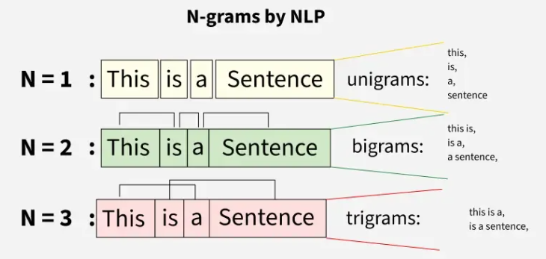
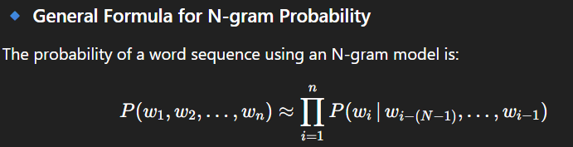

*Unigrams / Bigrams :-
Unigrams (1-grams):
These represent individual words within a text. For example, in the sentence "The cat sat on the mat," the unigrams are "The," "cat," "sat," "on," "the," and "mat." Unigrams are useful for understanding the frequency of individual words and are the basis of simple "bag-of-words" models, which treat text as an unordered collection of words.
Bigrams (2-grams):
These represent sequences of two consecutive words. Using the same example, "The cat sat on the mat," the bigrams would be "The cat," "cat sat," "sat on," "on the," and "the mat." Bigrams capture local word order and provide more contextual information than unigrams, allowing for the identification of common phrases or collocations.

